**1. Our understanding of celestial objects depends upon observations made from Earth or from space near the Earth**

***Discuss Galileo’s use of the telescope to identify features of the Moon***

* Galileo didn’t invent the telescope, but he refined the existing design such that he was able to magnify objects by 30 times. Thus, with the aid of the telescope, he studied the Moon and other celestial objects.
  + Galileo is largely considered to have been the first to demonstrate the usefulness of the telescope as an astronomical instrument that enhanced observation beyond what was possible with the unaided eye. In doing so, Galileo earned the title of “father of modern observational astronomy”.
* In regard to the Moon, he was able to:
  + calculate the height of lunar mountains (by measuring the length of the shadows they cast);
  + observe the existence of deep craters and valleys; and
  + map the terrain of vast plains.
* The observation of these ‘imperfections’ brought Galileo into conflict with the Church which purported the view that all ‘heavenly’ bodies were perfectly smooth and spherical, and thus could not possess any Earth-like features (e.g. mountains and valleys). In fact, at the time, Galileo’s telescope was described as by some in society as an ‘instrument of the devil’.
* Also, more generally, Galileo was able to observe:
  + four moons of Jupiter;
  + the phases of Venus (*very strong proof that Venus orbited the Sun)*; and
  + the existence of dark spots on the Sun.
* These observations also provided Galileo with evidence supporting the heliocentric model of the Universe, in contrast to the long-accepted and Church-endorsed geocentric model of the Universe.

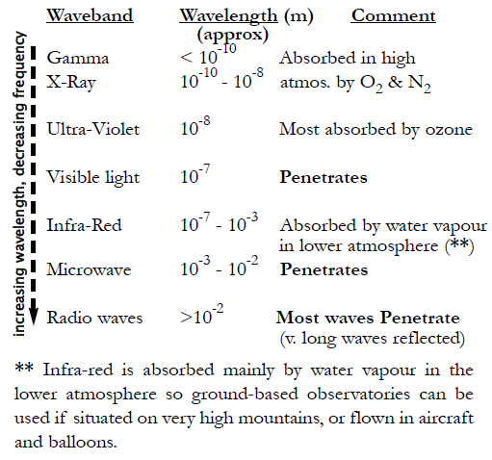***Discuss why some wavebands can be more easily detected from space***

* Not all electromagnetic radiation originating from space can penetrate the Earth’s atmosphere. Despite the whole electromagnetic spectrum being able to travel as far as the outer atmosphere, some wavebands are absorbed by various gases and ions found in the atmosphere and/or ionosphere.
* Therefore, only visible light, microwaves, short radio waves, and some UV radiation are able to make it through to the Earth’s surface.
* The reasons for the selective absorption/reflection of electromagnetic wavebands are discussed in the picture to the right.
* The implication of this is that ground-based astronomy is restricted to the visible, radio and near infrared wavelengths, to which the Earth’s atmosphere and ionosphere is relatively ‘transparent’.
* Consequently, observation of other wavebands of EMR is required to be carried out either from a plane, high-altitude balloon (in the upper atmosphere) or from an orbiting spacecraft (above the atmosphere).
* Note – It is important to remember that the ‘boundaries’ between different wavebands are not precise and the ‘regions’ commonly overlap to some extent.

***Define the terms ‘resolution’ and ‘sensitivity’ of telescopes***

* The effectiveness of ground-based telescopes in observing distant stars and galaxies depends upon many factors. In particular, of importance is the telescope’s resolution and sensitivity.
* The *resolution* of a telescope refers to its ability to distinguish two objects, close in angular separation, as distinct images. A good analogy for this is that our eyesight cannot resolve the distant headlights of a car into two separate sources of light until the approaching car is sufficiently close for the angular separation of the headlights to overcome the limited resolving power of our eyes.

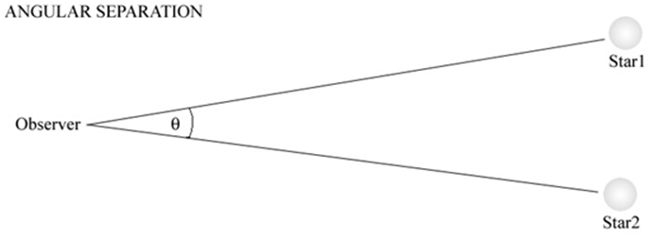

* The formula for resolution is $R=\frac{\left(2.1×10^{5}\right) × λ}{D}$, where:
  + R is the minimum angle of resolution, in arcseconds (arcsec)
  + λ is wavelength of the incoming wave, in metres (m)
  + D is diameter of the telescope’s primary lens/mirror, in metres (m)
* Hence, by referring to the formula, it can be seen that resolution is measured as an angle, and it depends upon the wavelength of the electromagnetic wave being collected and the diameter of the telescope.
* A smaller angle means that the objects can be closer together and still be distinguished from each other. Hence, a smaller value for R indicates a higher resolution. This means that resolution increases if the wave is of a lower wavelength or if the telescope has a greater diameter, as per the formula.
* The resolution of a ground-based telescope can be increased by:
  + increasing the diameter of the primary lens/mirror, resulting in a larger collecting area
  + interferometry (*discussed below*)
* The *sensitivity* of a telescope refers to its ability to pick up faint objects for observation (i.e. the magnitude of its light-gathering power). This depends upon the collecting area of the primary lens or mirror, since a larger area means more incoming light is being gathered and focused to form an image. The collecting area depends upon its radius and, hence, its diameter (which is the dimension usually quoted). Therefore, a larger diameter telescope will usually be a more ‘sensitive’ one.
* In fact, sensitivity is proportional to the cross-sectional area of the objective lens or mirror. Hence, as the area is proportional to the square of the radius, doubling the telescope’s radius would increase its sensitivity by a factor of four.
* Subsequently, although they have much lower resolutions, radio telescopes have high sensitivities, due to their very large collecting areas that result from their large diameters.
* The sensitivity of a ground-based telescope can be increased by:
  + increasing the radius of the telescope’s primary lens/mirror, thus increases its cross-sectional area
  + extending the period over which light is collected so that the total radiation gathered is increased

***Discuss the problems associated with ground-based astronomy in terms of resolution and absorption of radiation and atmospheric distortion***

Resolution

* By using the formula above, the Parkes radio telescope (with a 64 metre diameter) has a theoretical resolution of around 98 arcsec when observing radio waves of wavelength 3 centimetres. In contrast, the Anglo-Australian telescope (with a diameter of only 3.9 metres) has a theoretical resolution of around 0.027 arcsec when observing starlight of wavelength 500 nanometres.
* Therefore, these calculations make evident that radio telescopes, although they typically have much greater diameters, are restricted to very poor resolutions, due to the wavelengths they observe.
* Another problem is that the resolution of images produced by ground-based optical astronomy is limited by the diameter of the telescope’s primary mirror/lens. Although resolution does increase with diameter, technical and engineering limitations do exist in regard to creating large mirrors with sufficiently accurate dimensions that are not severely affected by environmental factors, such as temperature variations.
  + For example, for ground-based refracting telescopes, the primary lens can only be supported at its edges, since incoming waves have to pass through the objective lens. Therefore, as the size and weight of the lens is increased, increasing deformation of its shape occurs due to gravity, and this detracts from the resolution of the image.
* Also, resolution can be adversely affected by:
  + aberrations – i.e. faults or imperfections in the lens or mirror
  + diffraction– i.e. the bending of the EM wave around objects or through gaps

Absorption of Radiation

* As seen in a dot-point above, the atmosphere absorbs or reflects many of the wavebands of the EMR spectrum and, therefore, this limits which ones are available for ground-based astronomy (e.g. most UV rays are absorbed by the ozone layer).
* **Note**: It should be obvious that the effects of absorption of radiation can be eliminated if the telescope is placed in space. The cost, however, is prohibitive in all but a few cases (e.g. the Hubble Space Telescope cost over a billion dollars to build and put into orbit). Such Earth-orbiting satellites have been fitted with telescopes for all wavelengths.

Atmospheric Distortion

* On a very hot day, a person might see ripples rising from the surface, because pockets of moving hot air distort the light passing through it. In a similar manner, constantly moving warm pockets of air distort the path of starlight passing through the Earth’s atmosphere, thus resulting in the star appearing to twinkle and its image being blurred. This is known as *“seeing”*. It is defined as the twinkling and blurring of a starlight due to atmospheric distortion.
* Therefore, “seeing” (resulting from atmospheric distortion) means that, in practice, the actual resolutions of most telescopes are not as great as the theoretical resolutions that are suggested by calculations. For example, the Anglo-Australian Telescope is restricted, due to “seeing”, to a resolution of about 1 arcsec, despite its theoretical resolution of around 0.03 arcsec. In fact, most Earth-based optical telescopes are limited (by “seeing”) to a resolution of no better than 1 arcsec, regardless of their theoretical resolution.
* Note, “seeing” mostly affects wavelengths shorter than a centimetre. Thus, since most radio telescopes observe radio waves with wavelengths longer than this, they are affected much less by “seeing”.
* The last two problems discussed (absorption of radiation and atmospheric distortion) can be minimised by placing ground-based telescopes as high as possible (e.g. on mountains). This works because:
  + incoming waves have to penetrate less atmosphere and, thus, less of the light and infrared wavelengths are absorbed by haze, pollution and water vapour (largely found in the lower few kilometres of the atmosphere)
  + at higher altitudes, temperature tends to be more uniform, hence, resulting in less “seeing”
    - also, at higher altitudes, there is the advantage of remoteness from human activity and thus the effects of light pollution are less severe

***Outline methods by which the resolution and/or sensitivity of ground-based systems can be improved, including:***

* 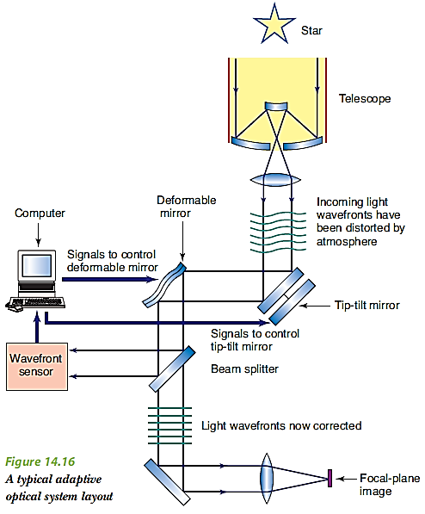***adaptive optics***
* ***interferometry***
* ***active optics***

Adaptive Optics

* ***Adaptive optics*** is a technique that involves measuring and then compensating for the effects of atmospheric turbulence upon starlight.
* Its set-up is shown in the diagram.
* The system works by the wavefront sensor sampling the light from a bright “reference star” up to 1000 times a second and computer-analysing the data to gauge distortion effects. The computer then controls rapid corrections made to the shape of the ‘deformable mirror’ and the orientation of the ‘top-tilt mirror’ to correct the distortions in the starlight.
* The ‘shape-changing’ of the deformable mirror is achieved by piezoelectric actuators that line the back of the mirror and work rapidly to alter the shape of the mirror by as little as 4 nanometres.
* Adaptive optics systems are so effective that some rival the quality of the Hubble Space Telescope.
* Note: Adaptive optics can only be used in telescopes with a diameter of at least 2 metres.
* Note: If a bright reference star within the telescope’s typically narrow field of view can’t be found, astronomers will then produce an artificial reference star using a laser projected into the sky and backscattered off air molecules in the telescope’s field of view.

Interferometry

* ***Interferometry*** is defined as a technique mainly applied to optical and radio astronomy that combines data from several elements of an antenna array in order to achieve an image of higher resolution and sensitivity. It has been used to measure the diameters of nearby stars such as the red giant Betelgeuse.
* It involves linking two or more telescopes by computers, which combine the incoming signals from the separate telescopes to produce interference patterns. These interference patterns are then analysed, enabling an image with a resolution approaching those of the largest telescopes to be formed.
* For example, this has been done in New Mexico, to create the Very Large Array (VLA), which is made up of 27 movable radio dishes set out in a large Y pattern. Each dish is 25 metres in diameter but, after signals are sent from each dish via fibre optics to a central laboratory, they can provide a resolution equivalent to that of a dish 36 kilometres in diameter and a sensitivity equal to that of a dish 130 metres in diameter.
* When interferometry is used, the resolution of the images formed will then be determined by the maximum separation of the linked telescopes. Also, the sensitivity will also be improved due to the increase in the overall surface area being used to collect radiation, but this increase will be moderate.
* For these arrangements, note to ensure synchronisation, atomic clocks (accurate to at least a millionth of a second) may be placed at each telescope

Active Optics

* ***Active optics*** refers to the use of a slow feedback system to correct sagging or other deformities in the primary mirror of large modern reflecting telescopes.
* Most reflecting telescopes now use thinner mirrors (e.g. 20 cm thick). Such mirrors change shape, as they sag under their weight when changing direction or as it expands/contracts when temperature changes.
* To deal with this, after starlight leaves the primary mirror and before it reaches the final lens (which is where the eyepiece is usually found), the starlight is slowly sampled by a ‘wavefront sensor’. The sensor is a type of interferometer and is able to detect how the incoming starlight has been altered.
* By slowly sampling the starlight, the effects of deformities in the primary mirror are able to gauged, and thus a computer then calculates the required shape adjustments for the mirror. Piezoelectric actuators, fitted at the back of the mirror, are moved about once a minute to push/pull the mirror into the desired shape. As an example, the Gemini telescopes are each fitted with 120 actuators.
* Active optics is advantageous because, prior to its introduction, mirrors had to be constructed with thick mirrors (about one-sixth of the mirror’s diameter) to avoid deformation. Consequently, this increase in the mirror’s weight led to a higher cost of making and mounting the mirror. Therefore, the introduction of active optics not only improved the quality of ground-based astronomy, but it also reduced the costs associated with it.
* Note: The rapid image distortions caused by atmospheric turbulence are ignored by the image analysis system used in active optics systems and, thus, are not addressed by active optics. Active optics is able to ignore the effects of atmospheric turbulence by *slowly* sampling the collected starlight.
* ***Note:*** Active optics is generally not used in radio telescopes, because the physical structure of a radio telescope is able to maintain the shape of the reflective surface adequately, as it is not heavy and only measures longer wavelength electromagnetic radiation.
* One similarity to be noted between active optics and adaptive optics is that both use a wavefront sensor to detect distortion in the collected starlight as well as a reference star in order to analyse the distortions.

*Summary* 🡺 This table, on the next page, sums up the similarities and differences between the three methods that were discussed above:

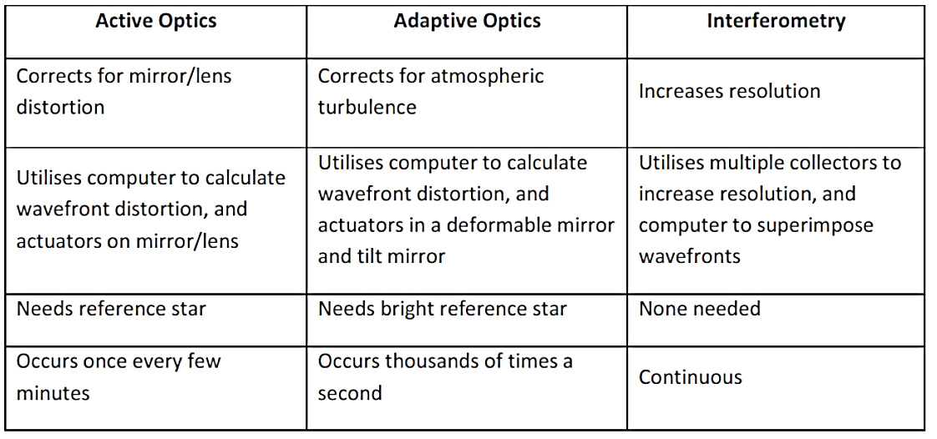

* *Example HSC Q* 🡺
  + **Question** 🡪 Interferometry and active optics are techniques that can be used to improve the resolution and/or sensitivity of ground based telescopes. Explain why only one of these techniques is useful in improving the resolution and sensitivity of radio telescopes.
  + **Solution** 🡪

Interferometry is as a technique that combines data from several elements of an antenna array in order to achieve an image of higher resolution and sensitivity. It is a useful technique for radio telescopes, because the resolution (resolution∝diameter) is then determined by the maximum separation of the collecting elements, which may be separated by thousands of kilometres. Sensitivity is also improved due to the effective increase in collecting surface area, due to the addition of linked telescopes. However, the increase in sensitivity is moderate and not as substantial as that of resolution.

On the other hand, active optics refers to the use of a slow feedback system to correct sagging or other deformities in the primary mirror of large telescopes. Active optics is not that useful for radio telescopes, because the wavelength of collected radiation is quite large and thus acceptable errors in the shape of the collecting surface can be much larger. Furthermore, the reflective surface used is not too heavy, so deformation is much less. In this way, the physical structure of most radio telescopes means that they are able to maintain the shape of the reflective surface adequately, without the use of active optics.

***Identify data sources, plan, choose equipment or resources for, and perform an investigation to demonstrate why it is desirable for telescopes to have a large diameter objective lens or mirror in terms of both sensitivity and resolution***

* Here’s how to carry out this investigation:
  + Create a chart with two black rectangles close together and stick this chart on the whiteboard.
  + Then, get your hands on a small telescope and a pair of binoculars.
  + Through both devices, look at the whiteboard from varying distances away and determine the maximum distance apart such that the gap between the rectangles can still be discerned.
  + Repeat the process for looking at the whiteboard using simply the naked eye.
  + It should be discovered that the distance away such that the two rectangles can still be discerned as separate is largest for the small telescope, next largest for the binoculars and smallest for the naked eye.
  + This demonstrates how the resolving power of the telescope is superior to that of binoculars, while the pair of binoculars possesses a better resolution than the naked human eye. This can largely be explained by how the telescope has an objective lens/mirror of the largest diameter, followed by pair of binoculars, and then the human eye.
  + Also, notice how as we moved from the telescope to the binoculars to the naked eye, the contrast between the chart (i.e. the paper) and the rectangles decreased. This demonstrates how the reduction in the diameter of the objective lens/mirror results in reduced sensitivity.